The Housing Authority of the City of Greenville (TGHA) created its 5 year plan covering the years 2015-2019 as part of the 2019 Annual Plan. Each year with the submission of the annual plan, TGHA will provide an update in the Progress Report. The goals and key initiatives will remain the same for the five-year period. Updates and progress made on achieving those goals and key initiatives are described below in the highlighted boxes.

Goals and Objectives. Identify the PHA’s quantifiable goals and objectives that will enable the PHA to serve the needs of low-income and very low-income, and extremely low-income families for the next five years. Include a report on the progress the PHA has made in meeting the goals and objectives described in the previous 5-Year Plan.

GOALS & KEY INITIATIVES FOR FY 2015 - 2019

- REPOSITION THE PUBLIC HOUSING PORTFOLIO: To reposition our housing portfolio and lessen our dependence on federal funding we will continue to use the successes of the federal Mixed Finance Program and the Rental Assistance Demonstration Program.

Heritage – This site is the remaining land on the former JJT HOPE VI Project. TGHA intends to solicit a new development partner and complete the development of approximately 72 senior units pursuant to the HUD approved Revitalization Plan and the City approved Planned Unit Development (PUD) amendment.

Updates and Progress
Heritage at Sliding Rock, located at 125 Ramsey Drive, Greenville, SC, will become a three-story building with 42 one-bedroom and six two-bedroom apartments for seniors ages 62 and older. It will also offer 12 two-bedroom cottages.

Development Timeline:
- August 2015: Received 9% Low Income Housing Tax Credit Allocation (60 unit senior housing built on 6 acres of
existing land at the current Heritage community)
- March 2016: Financial closing
- May – June 2017: Construction
- June 24, 2016: Groundbreaking Ceremony
- July 2017: Certificate of Occupancy
- September 1, 2017: 100% leased

Approximately 3 acres on undeveloped land remaining. The 3 acres are a part of a PUD to include the development of 25 for sale single family homes.

Chamlee – This site is a vacant parcel remaining after the demolition of the Chamlee Court public housing community. TGHA intends to dispose of this site at fair market value and utilize the sales proceeds towards the other affordable housing projects detailed herein.

Updates and Progress
Chamlee Court vacant parcels continues to be assessed for future use.

Scott Towers/Garden Apartments – TGHA will complete a Master Plan for the site to include the redevelopment of Garden Apartments. A new development partner will be procured to redevelop the site in accordance with the Master Plan. The existing Garden units will be converted from Public Housing to Project Based voucher units under the RAD Program.

Updates and Progress
Procured Pazdan, McMillan and Smith architects and completed conceptual plan. Actively working on the RAD conversion of Garden Apartments for the substantial rehabilitation of existing apartments and common areas.
Development Plans Phase I:
- RAD conversion of Garden Apartments and substantial rehabilitation of existing apartments and common areas
- New construction of additional affordable senior housing units

Development Plans Phase II:
- New construction of family units on the site, affordable and market rate (workforce housing)

Development Timeline:
- September 30, 2015: Selected Integral Group as our development partner
- July 2017: Creative Builders selected as the General Contractor
- Fall of 2018: Anticipated Phase I financial closing
- Late 2019/Early 2020: Complete development of Phase I
- Late 2021/Early 2022: Complete development of Phase II

Westview Homes & Brookhaven – TGHA secured a development partner for the redevelopment of these sites. The overall redevelopment plan will include four components:

- Phase I – The Manor at West Village Greenville: 55 unit new construction senior building.
- Phase II – The Harbor at West Village Greenville: Substantial rehabilitation of 57 multi-family units which includes the existing 55 units and 2 units currently used as the Resident Services Office; rehabilitation of the former Head Start Building for leasing; community space and Resident Services Offices. It also includes the Gallery at West Greenville.
- Phase III – The Haven at West Village: 42 unit new construction senior building and a new leasing and community building.
- Phase IV – The Gallery at West Village: demolition of 7 existing units; conversion of 18 one bedroom units to 12 units with art studios; and rehabilitation of the remaining 66 units.

Updates and Progress
Phase I - Manor at West Greenville
The Manor at West Greenville is located on 3.53 acres of land on the Brookhaven site. It includes 55 Senior Units (3 ACC Public Housing Units and 52 Project Based Vouchers).

Development Timeline:
- August 2014: LIHTC Allocation (9%)
- February 2015: Financial Closing
- May 2015 - August 2016: Construction
- June 2015: Groundbreaking Ceremony
- May 2, 2016 – May, 27, 2016: Applications taken on-line from
- August 2016: Received Certificate of Occupancy
- September 13, 2016: Open House
- November 2016: 100% Leased

Phase II - Harbor at West Greenville
Phased occupancy efforts are actively underway.

Development Timeline:
- April 18, 2016: Financial Closing
- April 25, 2016: Relocation began
- June 30, 2016: Relocation completed
- June - October 2017: Construction
- August – December 2017: Phased Occupancy
- June 2018: 100% Leased

Phase III – Haven at West Greenville
Submitted a funding application or to the United States Department of Treasury Capital Magnet Program with Community Works Carolina and the City of Greenville. The application was unsuccessful. Will resubmit for FY 2018 and also consider other forms of funding.
Development Timeline:
- 2020/2021 Project

Phase IV – Gallery at West Greenville
Received Certificate of Occupancy for 32 units. Executed Project-Based Voucher HAP Contract for an effective date of August 1, 2017. 32 units under lease effective August 1, 2017.

Development Timeline:
- April 18, 2016: Financial Closing
- April 25, 2016: Relocation began
- June 30, 2016: Relocation completed
- June - October 2017: Construction
- August – December 2017: Phased Occupancy
- June 30, 2018: 100% Leased

Scattered Sites – Of the existing 129 scattered site units, 14 are infeasible for repositioning and will be sold or demolished; 15 units will be sold to the existing tenants; and the remaining 100 units will be substantially rehabilitated and converted to Project Based Vouchers under the RAD Program.

Updates and Progress
TGHA converted 109 public housing single-family scattered site units to the Rental Assistance Demonstration Program. The remaining units were sold via a bid and/or disposition for public good process.

Development Timeline:
- July 1, 2016: Submitted RAD Financial Plan
- March 15, 2017: Received a RAD Conversion Commitment from HUD
- July 14, 2017: RAD Closing

PHASE I: Executed contract with general contractor on October of 2015. Comprehensive rehabilitation of 56 single family scattered site housing units. All units have been completely renovated and occupied.

PHASE II: Executed contract with general contract on April of 2016 to complete a comprehensive renovation of 53 single family scattered site units. All units have been completely renovated and occupied.

Ridgeway Apartments – This 8 unit senior property will be converted from Public Housing to Project Based Vouchers under the RAD program.

Updates and Progress
March 27, 2015, TGHA received the Rental Assistance Demonstration (RAD) Commitment to Enter Into Housing Assistance Payment (CHAP) award for Ridgeway Apartments. The agency has been assigned a RAD Transaction Manager and is currently working through milestones in preparation for closing and conversion from Public Housing to RAD (HCV Project Based Voucher Program).

Development Timeline:
- March 27, 2015: Received RAD Commitment to Enter Into Housing Assistance Payment (CHAP) award
- July 1, 2016: Submitted RAD Financial Plan
- June 28, 2017: Received a RAD Conversion Commitment from HUD
- August 30, 2017: Anticipated RAD Closing
- Completed

Elderly Designation Plan – Submit a Designated Housing Plan to HUD for approval to designate Garden Apartments, Charleston Place, Ridgeway and Arcadia (Senior) as occupancy by only elderly families.

Updates and Progress
- Manor at West Greenville – Elderly plan submitted and approved by HUD
- Heritage at Sliding Rock – Elderly plan submitted and approved by HUD
- Garden Apartments – Elderly plan will be submitted with the RAD closing; anticipated to occur in the 4th quarter of 2017
- Charleston Place – Elderly plan submitted and approved by HUD
Ridgeway Apartments – Elderly plan submitted and approved by HUD Arcadia Senior – Elderly plan submitted and approved by HUD

Project-Based Voucher Program – Maximize the 20% utilization of the Housing Choice Voucher Program for allocation of Project-Based Vouchers.

- Prioritize utilization efforts with TGHA identified development initiatives.
- Analyze efforts with private and/or for-profit developers for allocating project based VASH vouchers.

Updates and Progress
FY 2015 TGHA executed an Agreement to Enter into Housing Assistance Payment Contract (AHAP) contract for 52 units for the Manor at West Greenville and 99 units for the Harbor (formerly Brookhaven Apts) and Gallery of West Greenville (formerly Westview Homes PH).

FY 2016 TGHA executed Project Based Voucher AHAP contract for 60 units for the Heritage at Sliding Rock.

FY 2017

Executed PBV HAP contracts for the following developments;
- Manor at West Greenville 52
- Harbor & Gallery of West Greenville 99
- Heritage at Sliding Rock 60
Total = 211

ENTITIES IN PARTNERSHIP (Tax Credit Developments)
# | Property | CURRENT Unit Mix |  |  |  |  | FUTURE Unit Mix |  |  |  |  | DATE | UNIT TYPE
 |  | ACC | PBV | RAD | LIHTC | TOTAL | ACC | PBV | RAD | LIHTC | TOTAL |  | PBV | RAD/ PBV
1 | Manor at West Greenville | 3 | 52 |  | 55 |  |  |  |  |  |  | Aug-16 | 52
2 | Harbor at West Greenville | 12 | 45 |  | 57 | 57 |  |  |  |  |  | Aug-2017 | 45
 | Gallery at West Greenville |  | 54 |  | 66 | 66 |  |  |  |  |  | Nov- 2017 | 54
3 | Heritage at Sliding Rock |  | 60 |  |  | 60 |  |  |  |  |  | Aug-17 | 60
4 | Valley Creek |  |  |  | 48 | 48 |  |  |  |  |  | NA
5 | Preserve at Logan Park (Scott site) |  |  |  |  |  |  | 113 | 80 |  | 193 | Dec - 20 | 113 | 80
6 | Haven at West Greenville |  | 42 |  | 42 | 42 |  | 42 |  | 42 | 42 | Jan - 21 | 42
Subtotal |  | 15 | 211 | 0 | 226 | 286 | 15 | 155 | 80 | 42 | 235 | NA | 366 | 80
PUBLIC HOUSING CONVERSIONS TO RAD (Rental Assistance Demonstration)
# | Property | CURRENT Unit Mix |  |  |  |  | FUTURE Unit Mix |  |  |  |  | DATE | UNIT TYPE
 |  | ACC | PBV | RAD | LIHTC | TOTAL | ACC | PBV | RAD | LIHTC | TOTAL |  | PBV | RAD/ PBV
1 | Ridgeway Apts (RAD) | 8 |  |  |  | 8 |  |  |  |  |  | Aug-17 |  | 8
2 | Arcadia Hills (RAD) | 44 |  |  |  | 44 |  |  |  |  |  | Aug-17 |  | 44
3 | Scattered Sites (RAD) |  |  | 109 |  | 109 |  |  |  |  |  | July-17 |  | 109
4 | Garden Apts (RAD) | 80 |  |  |  | 80 |  |  | 80 |  | 80 | Dec-18 |  | 80
Subtotal |  | 132 | 0 | 0 | 0 | 241 |  |  | 80 |  | 80 | NA | 0 | 241
MIXED FINANCED DEVELOPMENTS (HOPE IV)
# | Property | CURRENT Unit Mix |  |  |  |  | FUTURE Unit Mix |  |  |  |  | DATE | UNIT TYPE
 |  | ACC | PBV | RAD | LIHTC | TOTAL | ACC | PBV | RAD | LIHTC | TOTAL |  | PBV | RAD/ PBV
1 | Charleston Place | 20 | 10 |  | 10 | 40 |  | 10 | 20 | 10 | 40 | Dec-18 | 10 | 20
2 | Evergreen Place | 75 | 35 |  | 58 | 168 |  | 35 | 75 | 58 | 168 | Dec-18 | 35 | 75
3 | Forest View | 29 | 36 |  | 7 | 72 |  |  |  |  |  | July - 18 | 151 | 29
4 | Nicholtown Green | 38 | 24 |  | 34 | 96 |  | 24 | 38 | 34 | 96 | Dec-18 | 24 | 38
5 | Clark Ridge Commons | 27 | 24 |  | 25 | 96 |  | 24 | 27 | 45 | 96 | Dec-18 | 24 | 27
Subtotal |  | 189 | 129 | 0 | 1545 | 472 | 0 | 103 | 160 | 137 | 400 | NA | 244 | 189
 | TOTAL | 336 | 340 | 109 | 380 | 999 | 0 | 258 | 320 | 179 | 715 | NA | 610 | 510

- OPERATIONAL EFFECTIVENESS: TGHA will continue to seek new business systems and improve existing work processes through an emphasis on technological innovations designed to improve customer service, enhance communication and reduce administrative burden and intensity of paperwork.

- Upgrade antiquated communications infrastructure to include computer hardware/software, phone system, network, etc.

- Secure Paperless Workflow Technology to increase operational efficiency.

- Continue implementation of paperless system in the Section 8 Housing Choice Voucher Department and begin incorporating paperless systems in the Low Rent Public Housing Department.

- Implement electronic signatures that comply with regulations, expedite business processes, and reduce operational costs.

- Update the agencies website and link it to a web portal that has access to the following portals:

- Landlord Portal for the Section 8 Housing Choice Voucher Program

- Tenant Portal for Low Rent Public Housing Residents

- Tenant Portal for Section 8 Housing Choice Voucher Program participants

- Applicant Portal for Low Rent Public Housing and Section 8 Housing Choice Voucher applicants

- Create a Point of Purchase System for goods and services and eliminate/reduce on site inventory.

- Secure Office location for Scattered Site Units.

Updates and Progress
- Issued a Human Resources Consultant Services RFP on March 31st with a closing date of May 4th. Currently working on contract terms and executive of contract with Human Capital Initiatives LLC. HCI’s scope of work will include by not limited to the following:
- Classification, compensation and benefits studies
- Succession Planning
- Evaluation of Staffing Levels and staff structure
- Development of Standard Operating Procedures
- Job Audits and Reclassification Analysis
- Evaluation of Integrated Payroll and Benefits Solution
- Installed VOIP Phone System in July of 2016. As of August 28, 2017 our call center processes approximately 3,500 calls per month. Transitioned dedicated servers to a virtualized robust and scalable cloud-based platform in September of 2016.

- Paperless Workflow Technology was secured and fully implemented in the HCV and Public Housing Program.

- The agency’s website has been updated and the status of each portal is listed below:

- HCV Program Landlord Portal -Complete
- Tenant Portal for the Low Rent Public Housing Program – anticipated implementation in 2018
- Tenant Portal for the HCV Program – anticipated implementation in 2018
- Applicant Portal – Complete

In addition to the portals listed above, the following portals have been created and fully functional

- Staff Portal
- Board Portal
- Rent Payment Portal (for the Manor at West Greenville and Valley Creek families)

- A Point of Purchase System for goods and services was created to eliminate/reduce on-site inventory.

- Single family scattered site units are serviced out of the Ridgeway Asset Management Office located on Industrial Drive.

- ENTREPRENEURIALISM:

- Sustainability through Diversification:

- Maximize use of Resources: Leverage current real estate assets to maximize return on investment that will assure organizational sustainability to continue to achieve the overall mission of the organization.

- Partnerships: Seek private public partnerships that maximize investment and seek new opportunities to generate additional revenue.

- Sound Business Practices:

- Superior Property Management: Exemplify qualities of a superior property management organization with regard to maintenance standards, tenant relations, leasing and communication and financial performance.

- Superior Non-Profit Management: Exemplify the qualities of a superior non-profit organized for public benefit. Focus will be retained on effective, accessible services and community building practices that increase stability and self-sufficiency of TGHA residents.

- Superior Administration: Administer the rent subsidy program with specific focus on program integrity, participant and owner relations, responsiveness to community needs and financial performance

- Superior Public Management: Exemplify the qualities of a well-run public agency through efficiency, fairness and integrity; TGHA will promote values and practices in support of fairness among people of all races and classes.

Updates and Progress
- Sustainability through Diversification

- Maximize Use of Resources

- TGHA leveraged current real-estate assets to maximize return on investment and that will assure organizational sustainability and continue to achieve the overall mission of the organization. Thus far TGHA has secured $578,550 from the ground lease payment, developer’s fees and pre-development loan repayment for The Manor at West Greenville, The Harbor & Gallery of West Greenville, and Heritage at Sliding Rock.

- Partnerships

- TGHA partnered with Douglas Development, Tapestry Development and Schaumber Development and secured two 9% LIHTC Awards and one bond 4% Bond deal;

- The Manor at West Greenville (55 Senior Units),

- Heritage at Sliding Rock (60 Senior Units) and

- Harbor and Gallery of West Greenville.

- TGHA also has a development partnership with the Integral Group for the re-development of the Scott Site.

- TGHA has created the following entities in partnership with its LIHTC Developments

ENTITIES IN PARTNERSHIP (Tax Credit Developments)
# | Entity | Property | Type of Entity | Date Created
1 | Greenville Redevelopment Corporation | - | 501 (c) 3 | 02.28.2014
2 | GRDC I, LLC | Manor at West Greenville | LLC | 02.28.2014
3 | GRDC II, LLC | Harbor and Gallery at West Greenville | LLC | 07.08.2014
4 | GRDC III, LLC | Heritage at Sliding Rock | LLC | 03.09.2015
5 | GRDC IV, LLC | Valley Creek | LLC | 6.24.2015
6 | GRDC V, LLC | Preserve at Logan Park | LLC | 02.22.2016
7 | GRDC VI, LLC | Charleston Place | LLC | 09.07.2017
8 | GRDC VII, LLC | Forest View | LLC | 03.22.2018
9 | GRDC VIII, LLC | Clark Ridge | LLC
10 | GRDC IX | Nicholtown Green | LLC
11 | GRDC X | Evergreen | LLC

- TGHA is in the process of creating and or have created the following entities for development of wholly owned TGHA properties

ENTITIES FOR DEVELOPMENT OF WHOLLY OWNED TGHA PROPERTIES
# | Entity | Property | Type of Entity | Date Created
1 | Greenville Area Housing Corporation | - | 501 (c) 3 | 9.08.2015
2 | GAH Ridgeway, LLC | Ridgeway Apartments (RAD) | LLC | 9.15.2015
3 | GAH Arcadia Hills, LLC | Arcadia Hills (RAD | LLC | 9.15.2015
4 | GAH Scattered Sites, LLC | Scattered Sites (RAD) | LLC | 9.15.2015
5 | GAH Garden Apartments, LLC | Garden Apartments (RAD) | LLC | TBA

- Sound Business Practices

- Superior Property Management

- REAC Scores for Scattered Site Properties increased from 60 in FY 2014 to 83 in FY 2015.

- Public Housing Program received a Public Housing Assessment System (PHAS) score of 92 for FYE 2014 = HUD High Performer Designation; FYE 2015 High Performer Designation and FYE 2016 High Performer Designation.

- Received a $30,000 grant from the United Way of Greenville to assist scattered site public housing over-housed residents in off-setting the cost associated with relocating to appropriate size units.

- Superior Non-Profit Management

- On February 26, 2015, HUD awarded $36 million in grants to public housing authorities and non-profit organizations across the nation to hire and retain service coordinators to help residents achieve economic and housing independence. TGHA was one of two public housing agencies in the state of South Carolina to receive an award. TGHA’s grant award totaled $246,000. These funds will also link the elderly and people with disabilities with supportive services that allow them to maintain independent living and age in place.

- Superior Administration

FYE 2015
- Housing Choice Voucher Program utilization increased from 90% in FYE 2014 to 98%.
- HCV Program Section Eight Management Assessment Program – HUD High Performer Designation
- Held a Housing Choice Voucher Program Landlord Workshop where over 160 landlords attended (2015).
- Increased the Housing Choice Voucher Program Payment Standard to 110% of the Fair Market Rent (2015)
- Increased Voucher Success rate from 21% in FYE 2014 to 51% in FY 2015.
- Clean Audit
- Began rightsizing all over-housed project based voucher and public housing families into appropriate size units

FYE 2016
- Housing Choice Voucher Program utilization increased from 98% in FYE 2015 to 99.9%
- HCV Program Section Eight Management Assessment Program – HUD High Performer Designation
- Voucher Success rate remains steady at 51% at a result of a tight rental market and a steady decline in available affordable housing stock.
- Clean Audit
- Completed rightsizing of all over-housed project based voucher and public housing families into appropriate size unis
- Entered into a Memorandum of Understanding (MOU) with United Housing Connections allocating 50 tenant based vouchers to house homeless individuals and families (2016).
- Partnered with Community Works Carolina to create a Landlord Assistance Program, which provides landlords with small loans that they can use to address Housing Quality Standards (HQS) repairs to units they’ve designated to lease to HCV Program participants.

FYE 2017
- Housing Choice Voucher Program utilization increased from 99.9$ to 100%
- Voucher Success rate remains steady at 51% at a result of a tight rental market and a steady decline in available affordable housing stock.
- Entered into a MOU with Soteria Corporation allocating 16 tenant based vouchers to house re-entry individuals.

FYE 2015-2016-2017-2018

- Applied for and received $3,130,000

 | 2015 | 2016 | 2017 | 2018
HCV Program
- Unforeseen Circumstances Set Aside |  | $1,090,755 |  | $316,009
- Portability | $15,131 | $152,706 |  | $39,167
- VASH – Veteran Vouchers |  | $122,779
- VASH Extraordinary Administrative Fees |  | $62,000
- Maintain Leasing | $527,444
Resident Opportunity and Self-Sufficiency
- ROSS Grant | $246,000 |  |  | $246,000
- Family Self-Sufficiency Grant | $101,393 | $101,393 |  | $101,393
- John Smith Charities |  |  | $7,800
TOTAL | 889,968 | 1,529,633 | $7,800 | $702,569

- Superior Public Management

- Procurement of goods and services are advertised publicly on our agencies website, the local newspaper and nationally via NAHRO E-Procurement.

- TGHA’s website interlinks with its social media pages and all solicitations, advertisements, press-releases, etc., are published on these platforms for transparency purposes.

- Received a clean audit FYE 2017, 2016 and 2015

FYE 2015

- TGHA updated its financial policies to include the following:

- Investment Policy: TGHA’s guide to invest public funds in a manner that will provide the highest investment return with the maximum security while meeting the daily cash flow demands of the organization while conforming to all federal, state and local statues governing the investment of public funds.

- Cash Receipts & Disbursement Policy: TGHA’s guide on how it handles and disburses cash, beginning with the authorization of account signatories.

- Accounts Payable Policy: Appropriate authorization for payment of invoices (PO’s, Contracts, etc.,)

- Payroll Policy: TGHA’s guide to tracking time and attendance, processing payroll.

- Revenue & Receivable Policy: TGHA’s guide to how it accounts for receipts for cash/funds. GAAP – Accrual Basis.

- Budgeting & Monthly Financial Reporting Policy: TGHA’s guide on the operating budget planning process and reporting of monthly financials to the Board of Commissioners.

- Board Travel Policy: TGHA’s guide on conducting business and advance training and professionalism of its Board of Commissioners to encourage attendance at business meetings, trainings, conferences and conventions.

- MARKETING: Enhance TGHA’s brand as a housing development entity through an effective marketing and communications plan.

- Strategically communicate TGHA’s successes, initiatives and capabilities to local leaders, businesses and stakeholders and partners in an effort to enhance the awareness of TGHA’s capabilities and contributions.

- Create marketing material to reflect TGHA’s new corporate brand (brochures, business cards, etc.,)

- Increase TGHA’s internet presence to communicate with our partners and customers (link website to business portals for vendors, landlords, tenants and applicants).

- Effectively utilize social media (Twitter, Linked In, Facebook, etc.,) to market and enhance TGHA’s Brand.

- Host and/or ensure an active presence in housing related events (April – Fair Housing Month, June – Homeownership Month).

- Publish an Annual Report, highlighting the agency’s successes and initiatives.

Updates and Progress
- Enhanced TGHA’s Awareness, Capabilities and Contributions

TGHA continues to communicate successes, initiatives and capabilities to local leaders by being active members of the following entities and/or have one of more employees as a member on a board or committee:

- Local Memberships
- Affordable Housing Strategy Steering Committee – City of Greenville
- Commitment Task Force
- Crime Free Multi-Family Housing Taskforce
- Greenville Chamber Of Commerce
- Greenville County Workforce Development Board – Youth Council
- Greenville Exchange Club
- Greenville Rotary Club
- Homeless Alliance of Greenville
- Leadership Greenville 42
- Nicholtown Child & Family Collaborative
- SC Works Greenville One-Stop Delivery System
- Upstate CREIA (Carolina Real Estate Investors Association)
- Upstate Greenville Apartment Association

- Statewide Memberships
- Institute for Real Estate Management (IREM) South Carolina Chapter No 72
- Carolina’s Council of Housing Redevelopment & Codes Officials (CCHRCO)
- South Carolina Housing Authority Executive Directors’ Association (SCHAED)
- South Carolina Resident Improvement Council (RIC)
- Urban Land Institute of South Carolina (ULISC)

- Regional Memberships
- Southeastern Affordable Housing Management Association (SAHMA)
- Southeastern Regional Council of NAHRO (SERC-NAHRO)
- Southeastern Regional Section 8 Housing Association (SERSHA)

- National Memberships
- CEO’s for Cities Greenville/Greer Cluster
- Housing Development Law Institute (HDLI)
- National Association of Housing Redevelopment & Codes Officials (NAHRO)
- Nelrod Consortium
- Public Housing Authority Directors’ Association (PHADA)
- Council of Large Public Housing Authorities (CLPHA)

TGHA purchased sponsorships and attended the following local corporate events:

- Table Sponsor at the 2017 Urban League’s Whitney M. Young Jr., Humanitarian Award Gala.
- Bronze sponsorship at the 2017 Greenville Chamber of Commerce in recognition of Net Nights.

- Enhanced TGHA’s Brand through Marketing Material

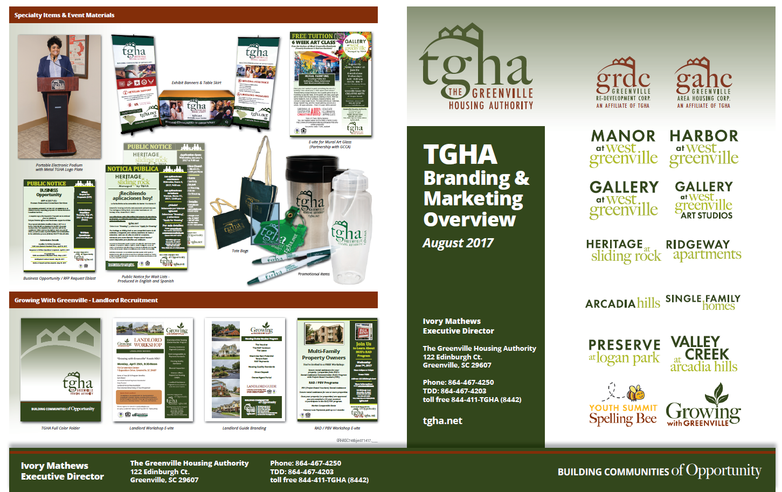

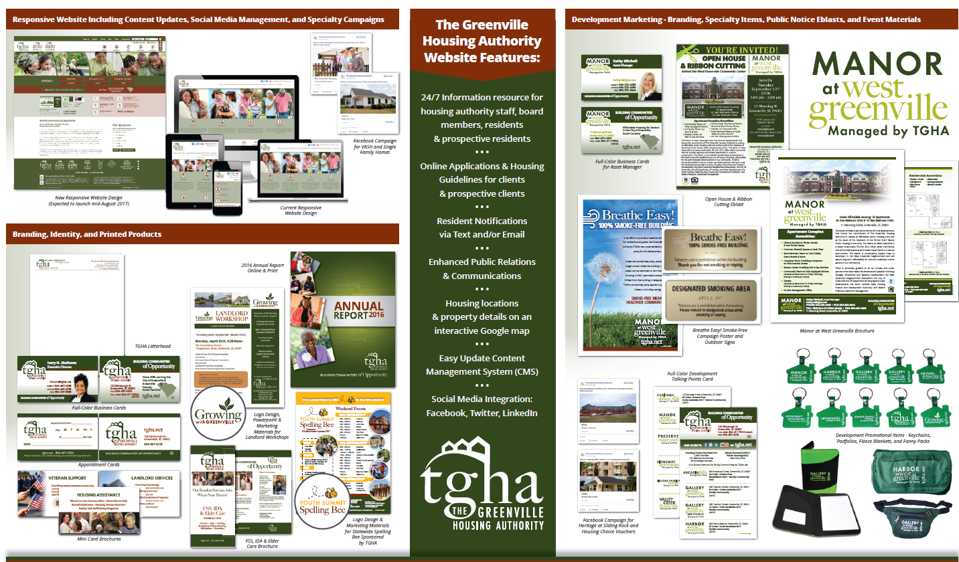

TGHA purchased a variety of marketing materials which are used in community events and one on one meetings with business partners.

TGHA purchased several advertisements in the South Carolina Black Pages 25 Anniversary Edition.

- Increase TGHA’s internet presence

  - 2018 CCHRCO Best Website of the Year Award | Extra-Large Public Housing Category
  - 2018 SERC-NAHRO Website of the Year Award |Extra-Large Public Housing Category
  - TGHA averages over 5,000 visitors per month on its agency website.
  - TGHA has over 3,000 subscribers on its website e-newslink.

- Effectively Utilize Social Media

TGHA created social media accounts and all are integrated within the agency’s website.

a. Twitter,
b. Facebook, and
c. LinkedIn

- Ensure and Active Presence at Housing Related Entities

- Staff attended the Housing Workshop hosted by Greenville County Human Relations in honor of Fair Housing Month.

- Attended the City of Greenville’s acknowledgement of the 40th Anniversary of the CDBG Program (groundbreaking ceremony for the new Genesis Homes Development).

- TGHA attended the SC Fair Housing Assessment Center Meeting hosted by Greenville County Human Relations.

- South Carolina Fair Housing Center hosted a community meeting in Greenville on August 6, 2015, TGHA attended.

- TGHA hosts an annual Landlord Workshop in 2015 (over 160 landlords attended) and 2016.

- TGHA hosted a VASH Housing Workshop in June of 2015.

- Publish Annual Report

- FYE 2015 Annual Report was released to the public in March of 2016.
- FYE 2016 Annual Report was released to the public in March of 2017.

- RESIDENT STRATEGIES: Assist residents in gaining access to education, employment opportunities and homeownership opportunities.

- Maintain Arcadia and other identified communities as stabilized homeownership communities.

- Expand homeownership opportunities through the sale of 15 units.

- Expand homeownership opportunities through the Section 8 Homeownership Program.

- Partner in an active advocacy role with local schools and colleges to facilitate access to educational opportunities for tenants.

- Ensure compliance with Section 3 in ensuring to the greatest extent possible, job training, employment, and contract opportunities are made available to low- or very-low income residents in connection with projects and activities in the neighborhoods where HUD funds are expended.

- Update the Low Rent Public Housing Lease Agreement.

- Enhance safety and security efforts for TGHA residents and the surrounding neighborhoods through active participation with the Crime Free Multi-Family Housing Program.

Updates and Progress
- Stabilize Homeownership Communities:

TGHA continues to ensure that Arcadia and other identified communities remain stabilized homeownership communities through the following efforts:

- Monitor the Arcadia Homeownership units to identify immediately those units that may be facing foreclosure (none were identified in FY 2015).

- Ensure that rental units in the Arcadia community remain esthetically appealing. FY 2015 TGHA performed pressure washing, painting, replacing eaves, gutters and downspouts, and addressed drainage concerns of the rental units located in the Arcadia community.

- Expand Homeownership Opportunities through the sale of 15 homes:

- TGHA has 26 vacant parcels in the Heritage Community that is zoned for single-family homeownership. TGHA will continue its efforts to seek a non-profit partner to build single-family homes for affordable homeownership opportunities.

- Expand Homeownership Opportunities through the Section 8 Homeownership Program:

  - There are currently eight (8) active participants with mortgages in the HCV Homeownership Program.

  - The HCV Program Administrative Plan has been revised to continue expanding homeownership opportunities for families with vouchers.

  - One (1) family purchased a home using the HCV in FY 2017.

- Educational Advocacy Role:

- TGHA has staff representation on the Nicholtown Child and Family Collaborative (Board Member) and the Greenville County Workforce Development Board - Youth Council.

- SERC-NAHRO (awards were announced in July 2015) - Dah’vielle Lucas was selected by SERC-NAHRO to represent South Carolina for a chance to win the SERC’s 75th Anniversary $7,500.00 scholarship. Ms. Lucas did not receive the final award but we are proud to announce that she will be attending Converse College on an Athletic Scholarship.

- CCHRCO – Brandon James and Hannah Faith Bickley Scholarship (one-year $1,000 scholarship)

- 2015 Awardees: Chase Dirton-Sullivan and Cedric Shell
- 2016 Awardee: Ahmere Robinson
- 2017 Awardee: Shanautika Simmons
- 2018 Awardee: Jeremiah Burns and Jaqueline Williams

- Nelrod & Associates (one-year $1,000 scholarship) – Former Commissioner Felsie Harris Academic Scholarship.

- 2017 Awardees: Ciorra Marbury, Destiny Hatcher and Shanautika Simmons
- 2018 Awardees: Jeremiah Burns, Desiree Ambercrombie, Mahogany Rector, Jacquelin Williams and Ciorra Marbury

- TGHA has registered and an active participant with ABCmouse.com Early Learning Academy, which is a comprehensive online learning program for children ages 2-7. The curriculum encompasses more than 6,000 individual learning activities and 500+ complete lessons for pre-school, pre-k, kindergarten and 1st grade, including reading and language arts, math, science, social studies, health, art, and music.

- Youth Reading Center: Our Youth Reading Center was made possible through a partnership with the Women of Ford Credit (WFC) who donated books& purchased furniture to create a library for pre-school and middle school children who are residents in TGHA properties.
The library currently contains over 400 books, of which 150 were received by the Library of Congress Books Surplus program. WFC also hosts a back to school drive every summer, just before school begins, to provide book bags & school supplies to the resident children of TGHA.

- Section 3 Compliance:

- TGHA continues to ensure compliance with Section 3 in ensuring, to the greatest extent possible, job training, employment, and contract opportunities are made available to low-or very-low income residents in connection with projects and activities in neighborhoods where HUD funds are expended.

- Update Low Rent Public Housing Lease Agreement:

- All of the developments under the Public Housing portfolio will transition to RAD no later than December 31, 2017. These development will use an approved lease agreement to include HUD-RAD PBV Riders and Addendums.

- Enhance Safety & Security:

- TGHA continues to enhance safety and security efforts for its residents and the surrounding neighborhoods through active participation with the Crime Free Multi-Family Housing Program.

- FY 2015 & 2016 TGHA applied for HUD’s Safety and Security Grant for installation of additional cameras at the Garden Apartments community. TGHA was not selected as one of the awardees, but will continue to pursue this and other grant opportunities in the future.

- TGHA has installed security cameras and key card accesses in all of its senior apartment buildings.

- VIOLENCE AGAINST WOMEN: To protect the rights of victims of domestic violence, dating violence, and stalking to secure and maintain housing without being victimized a second time by being denied housing or losing housing because of the criminally violent acts perpetrated against them.

- Ensure that all applicants and participants of the Housing Authority know of their rights under the VAWA.

- Implement VAWA as victims come forward to claim their rights.

- Educate participating landlords to assist them to protect the rights of victims and to avoid evictions where the victim can certify they qualify for protection.

- Link victims with resources in the community that can assist them with services.

- Work with the Domestic Violence Shelter to develop housing options for victims of domestic violence.

- Policies prescribed in the Public Housing Admissions for Continued Occupancy and the Section 8 HCV Program Administrative Plan will ensure the following;

- TGHA will not knowingly deny assistance to otherwise eligible applicants simply because they have been victims of domestic violence, dating violence, sexual assault, or stalking.

- TGHA will not knowingly terminate the assistance of otherwise compliant persons simply because they are victims of domestic violence, dating violence, sexual assault, or stalking.

- TGHA will educate applicants and participants of their rights under VAWA.

- TGHA will work to educate landlords about VAWA and the rights of victims under the act and to work with the landlord and the victims to protect the housing assistance of victims and their families.

Updates and Progress
- Ensure Applicants and Participants Know Their Rights Under VAWA

  - VAWA regulations are included as an addendum to the Public Housing Lease Agreement.

  - HUD Form 50066, Certification of Domestic Violence, Dating Violence, Sexual Assault, or Stalking is listed on TGHA’s website under the Resident Link, included in the HCV Tenant Briefing and Public Housing Leasing packets.

- Implement VAWA as Victims Come Forward to Claim Their Rights

- VAWA is being implemented as victims come forward to claim their rights.

- Educate Landlords About VAWA

- HUD Form 50066, Certification of Domestic Violence, Dating Violence, Sexual Assault, or Stalking is included in the HCV Landlord Briefing packets.

- Link Victims With Resources

- Individuals experiencing domestic violence are referred to shelters and other community agencies providing services for individuals experiencing domestic violence.

- Work With the Domestic Violence Shelter

- We work with domestic violence shelters in referring individuals who are in need of VAWA services.

- Prescribed Public Housing and HCV Policies

- VAWA is outlined under Section 1.14 of the Housing Choice Voucher Program Administrative Plan.

- VAWA is outlined under Section 1.13 of the Public Housing Program Admissions for Continued Occupancy Plan.

